**Name: Rahul Surana**

**30th October assignment**

**Assignment 1 :-** Create an IAM user with username of your own wish and grant

administrator policy

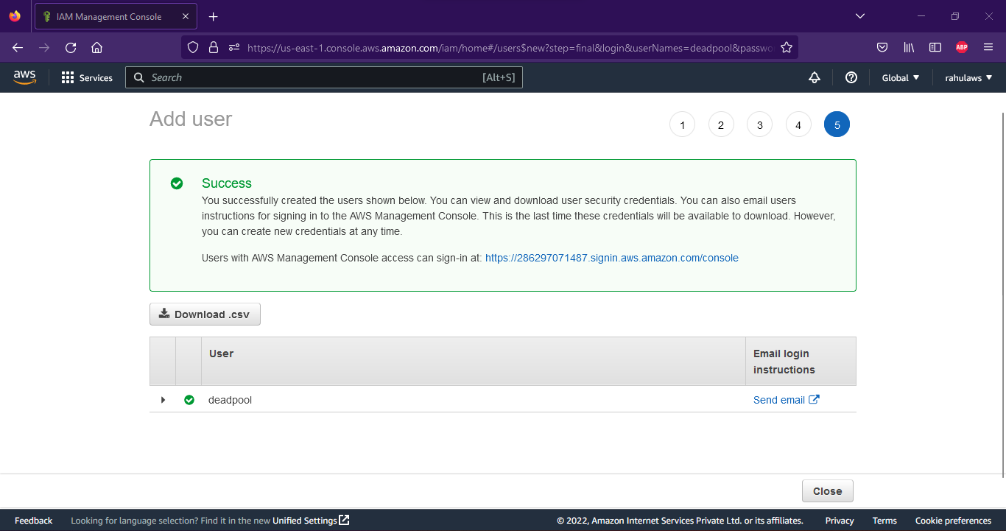

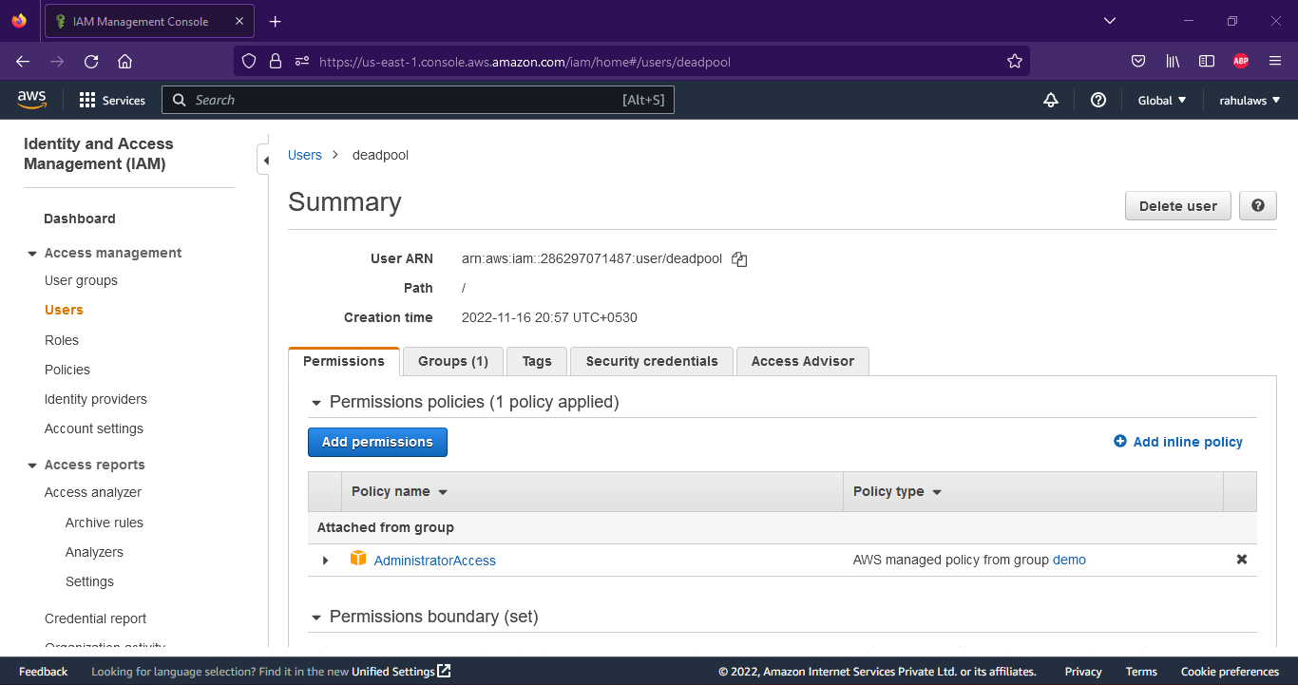

**Assignment 2 :-** Hello students, in this assignment you need to prepare a developers team of avengers.

- Create 3 IAM users of avengers and assign them in developer’s groups with IAM policy.

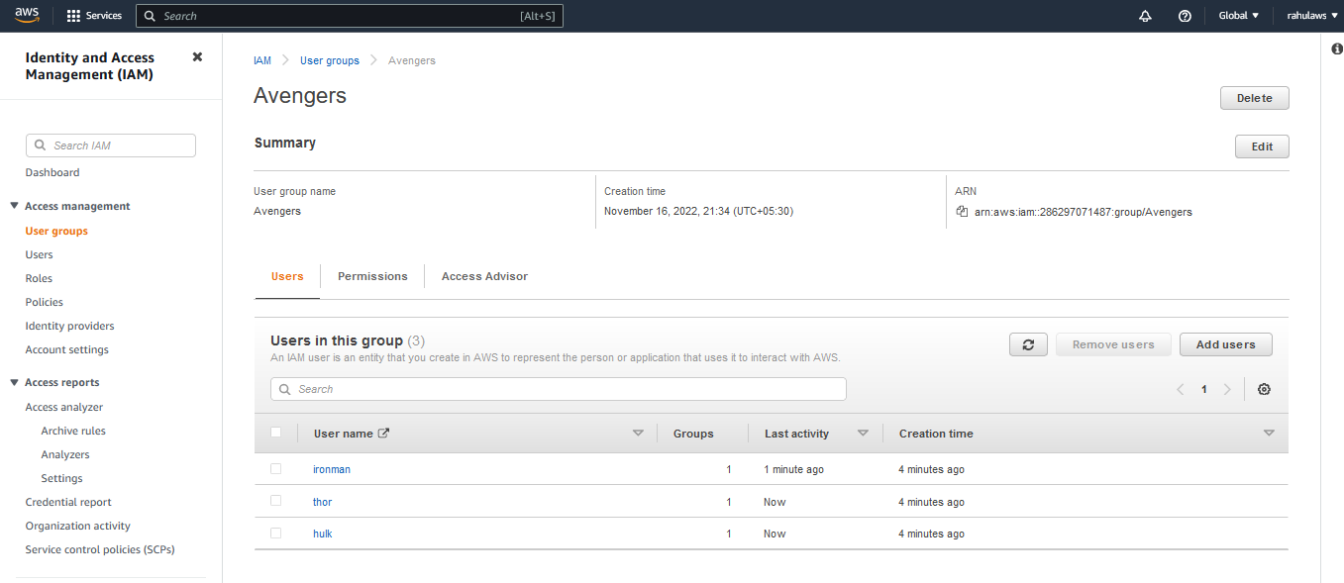

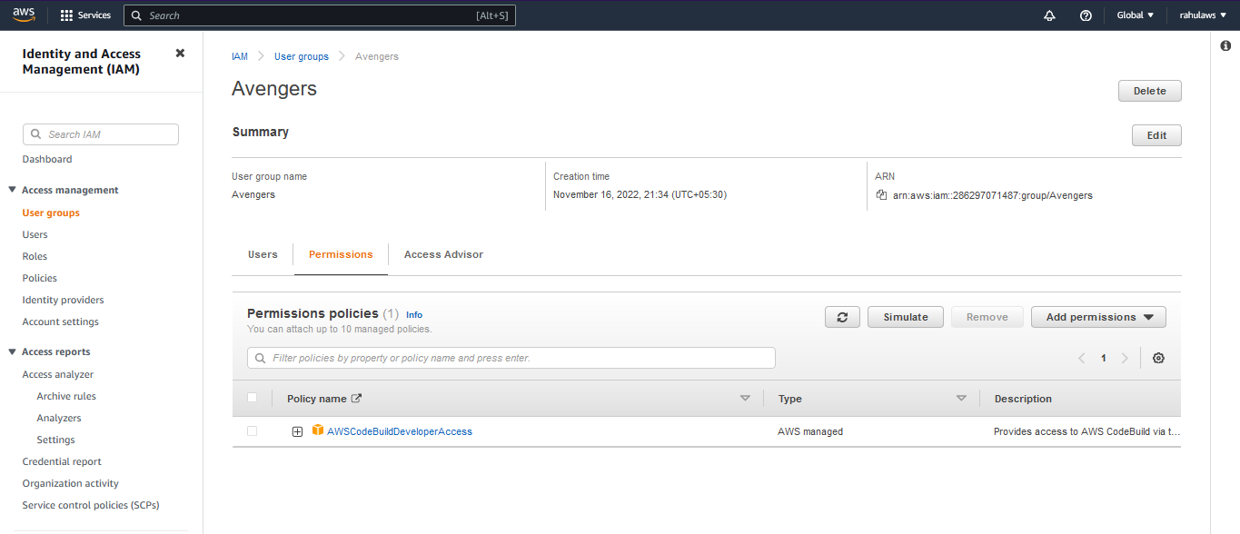

**Assignment 3 :-** Define a condition in policy for expiration like

"DateGreaterThan": {"aws:CurrentTime":

"2020-04-01T00:00:00Z"},

"DateLessThan": {"aws:CurrentTime":

"2020-06-30T23:59:59Z"}

Define the span of 4 months as per your wish.

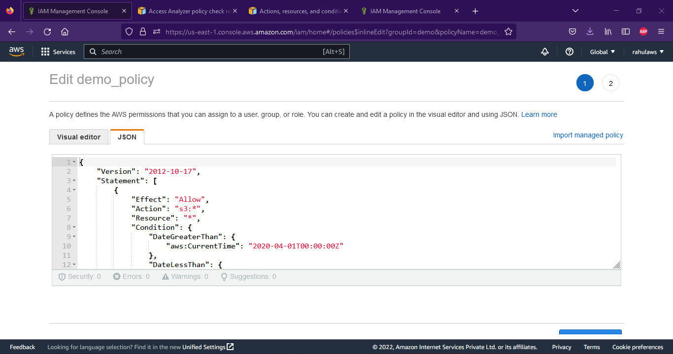

**Assignment 3 :-** Prepare 15 authentic MCQ questions related to IAM.

1. What is IAM and what is it used?
2. What is the difference between Users and Groups in IAM?
3. Can a user be in multiple groups?
4. Can a group contain another group?
5. What policy is almost similar to root given to an employee?
6. What are policies?
7. How many policies do AWS provide for AdministratorAccess?
8. Can we assign multiple new/more policies later for a user?
9. What are the ways to assign policies to a user?
10. Why it is not suggestable to use a root user and instead an IAM user with proper policies in given to a user?
11. Name a few policies that can be assigned to a user
12. Can we delete a user/group. Explain.
13. Can a user delete a root account and vice-versa?
14. Can you assign multiple users to a group at the same time?
15. How will you keep logs of all the users created in IAM?

**Assignment 4 :-** Launch your linux instance in IAM and update your machine.

